LAB - 8

Name - Eishaan Khatri

Roll No. - 22mc3014

Q1)

import React, { useState } from 'react';

const CurrencyConverter = () => {

const [amount, setAmount] = useState('');

const [fromCurrency, setFromCurrency] = useState('USD');

const [toCurrency, setToCurrency] = useState('INR');

const exchangeRate = 88.47;

const handleAmountChange = (e) => {

setAmount(e.target.value);

};

const handleFromCurrencyChange = (e) => {

setFromCurrency(e.target.value);

};

const handleToCurrencyChange = (e) => {

setToCurrency(e.target.value);

};

const convertCurrency = () => {

const convertedAmount = amount \* exchangeRate;

return convertedAmount.toFixed(2);

};

return (

<div>

<h2>Currency Converter</h2>

<div>

<label htmlFor="amount">Amount:</label>

<input type="number" id="amount" value={amount} onChange={handleAmountChange} />

</div>

<div>

<label htmlFor="fromCurrency">From Currency:</label>

<select id="fromCurrency" value={fromCurrency} onChange={handleFromCurrencyChange}>

<option value="USD">USD</option>

<option value="EUR">EUR</option>

{/\* Add more currencies as needed \*/}

</select>

</div>

<div>

<label htmlFor="toCurrency">To Currency:</label>

<select id="toCurrency" value={toCurrency} onChange={handleToCurrencyChange}>

<option value="USD">USD</option>

<option value="INR">EUR</option>

{/\* Add more currencies as needed \*/}

</select>

</div>

<div>

<button onClick={convertCurrency}>Convert</button>

</div>

<div>

{amount && (

<p>

{amount} {fromCurrency} is equal to {convertCurrency()} {toCurrency}

</p>

)}

</div>

</div>

);

};

export default CurrencyConverter;

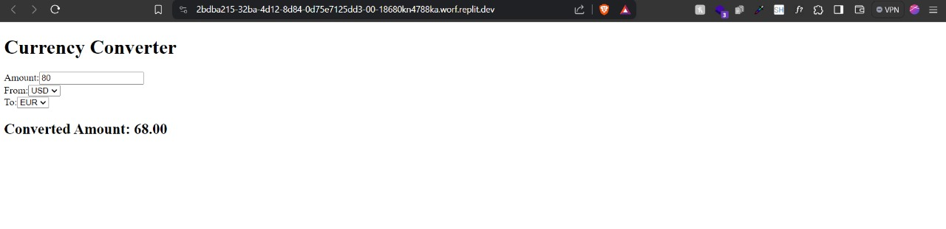

Q2)

import React, { useState, useRef } from 'react';

const Stopwatch = () => {

const [time, setTime] = useState(0);

const [isRunning, setIsRunning] = useState(false);

const intervalRef = useRef(null);

const startStopwatch = () => {

if (!isRunning) {

setIsRunning(true);

intervalRef.current = setInterval(() => {

setTime(prevTime => prevTime + 1);

}, 1000);

}

};

const pauseStopwatch = () => {

clearInterval(intervalRef.current);

setIsRunning(false);

};

const resetStopwatch = () => {

clearInterval(intervalRef.current);

setTime(0);

setIsRunning(false);

};

const formatTime = (timeInSeconds) => {

const hours = Math.floor(timeInSeconds / 3600);

const minutes = Math.floor((timeInSeconds % 3600) / 60);

const seconds = timeInSeconds % 60;

return ${hours.toString().padStart(2, '0')}:${minutes.toString().padStart(2, '0')}:${seconds.toString().padStart(2, '0')};

};

return (

<div>

<h2>Stopwatch</h2>

<p>{formatTime(time)}</p>

<div>

{!isRunning ? (

<button onClick={startStopwatch}>Start</button>

) : (

<button onClick={pauseStopwatch}>Pause</button>

)}

<button onClick={resetStopwatch}>Reset</button>

</div>

</div>

);

};

export default Stopwatch;

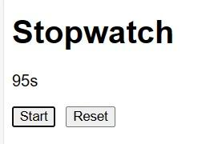

Q3)

import React, { useState, useEffect } from 'react';

import firebase from 'firebase/app';

import 'firebase/database';

const firebaseConfig = {

// Your Firebase configuration

};

firebase.initializeApp(firebaseConfig);

const MessagingApp = () => {

const [conversations, setConversations] = useState([]);

const [selectedConversation, setSelectedConversation] = useState(null);

const [newMessage, setNewMessage] = useState('');

useEffect(() => {

const conversationsRef = firebase.database().ref('conversations');

conversationsRef.on('value', (snapshot) => {

const data = snapshot.val();

if (data) {

setConversations(Object.values(data));

}

});

}, []);

const selectConversation = (conversation) => {

setSelectedConversation(conversation);

};

const sendMessage = () => {

if (newMessage.trim() === '') return;

const conversationRef = firebase.database().ref(conversations/${selectedConversation.id}/messages);

conversationRef.push({

text: newMessage,

sender: 'user', // or you can set it to the user's ID if you have user authentication

timestamp: firebase.database.ServerValue.TIMESTAMP

});

setNewMessage('');

};

return (

<div>

<h2>Conversations</h2>

<ul>

{conversations.map(conversation => (

<li key={conversation.id} onClick={() => selectConversation(conversation)}>

{conversation.title}

</li>

))}

</ul>

{selectedConversation && (

<div>

<h3>{selectedConversation.title}</h3>

<div>

{selectedConversation.messages.map(message => (

<div key={message.id}>

<p>{message.text}</p>

<small>{message.sender}</small>

</div>

))}

</div>

<input type="text" value={newMessage} onChange={(e) => setNewMessage(e.target.value)} />

<button onClick={sendMessage}>Send</button>

</div>

)}

</div>

);

};

export default MessagingApp;